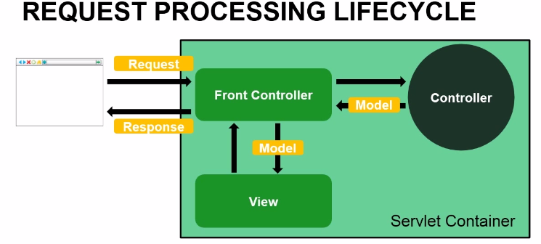

Web.xml

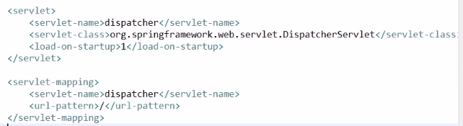

<load-on-startup> tells the servlet to load when we load our web application and it should be the first servlet to load.

DispatcherServlet servers as Front Controller. When the DispatcherServlet is loaded Spring is going to look for a configuration file named <servlet-name>-servlet.xml (defines servlet container’s behaviour) under WEB-INF directory. Example in our case it is going to look for dispatcher-servlet.xml

Web.xml

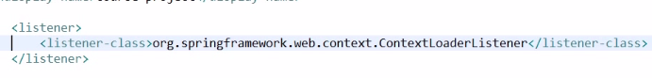

Spring will look for applicationContext.xml in WEB-INF directory.

Web.xml

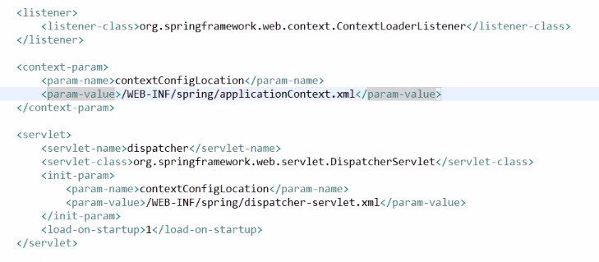

If the applicationContext.xml or dispatcher-servlet is moved to a different directory instead of being in the default directory, then the location should be specified in init-param or context-param as you see above.

dispatcher-serverlet.xml

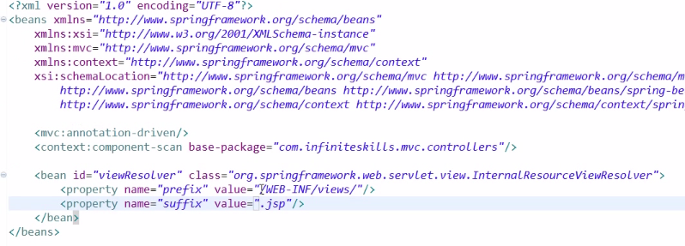

Annotation-driven enables no of features in Spring MVC especially the annotations.

Component-scan scans for all the controillers in the given package.

View resolver user prefix and suffix to locate the JSP files example if controller returns “home” then it will prefix and suffix as /WEB-INF/views/home.jsp

Dispatcher-servlet.xml

Static resources like css, .js are mapped with the below tag. 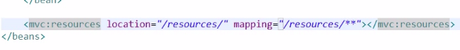

Location resources is under the webapp directory. \*\* is an ANT style path mapping. This allows it to map URIs’ that may have additional forward slashes.